Project Proposal
Room Bridge


Student
Ahtisham Ali Mustafa
S23BINFT1E02034
Course
Final Year Project
Supervisor
Ms. Sara Farid

DEPARTMENT OF Information Technology
THE ISLAMIA UNIVERSITY OF BAHAWALPU

Revision History
Version | Date | Description | Author
1.0 | April 2026 | Initial SRS Document | Ahtisham Ali Mustafa

Table of Contents
Revision History 1
Table of Contents 1
1. Introduction 1
1.1 Purpose 1
1.2 Project Scope 1
1.3 Definitions, Acronyms, and Abbreviations 1
1.4 References 1
1.5 Overview of Document 1
2. Overall Description 1
2.1 Product Perspective 1
2.2 Product Functions 1
2.3 User Classes and Characteristics 1
2.4 Operating Environment 1
2.5 Design and Implementation Constraints 1
2.6 Assumptions and Dependencies 1
3. Functional Requirements 1
3.1 User Authentication & Authorization Module 1
3.2 Room Listing Management Module (Room Owner) 1
3.3 Room Search & Discovery Module (Room Seeker) 1
3.4 Roommate Compatibility Matching Module 1
3.5 Real-time Chat Module 1
3.6 Review & Rating Module 1
3.7 Notification Module 1
3.8 Admin Dashboard Module 1
4. Non-Functional Requirements 1
4.1 Performance Requirements 1
4.2 Security Requirements 1
4.3 Usability Requirements 1
4.4 Reliability & Availability 1
4.5 Maintainability & Scalability 1
4.6 Portability Requirements 1
5. System Models 1
5.1 Use Case Descriptions 1
5.2 Data Flow Overview 1
5.3 Database Entity Overview 1
6. External Interface Requirements 1
6.1 User Interface 1
6.2 Hardware Interfaces 1
6.3 Software Interfaces 1
6.4 Communication Interfaces 1
7. Appendices 1
7.1 Appendix A — Roommate Compatibility Questionnaire 1
7.2 Appendix B — Technology Stack Summary 1
7.3 Appendix C — Requirements Traceability Matrix 1

1. Introduction

1.1 Purpose
This Software Requirements Specification (SRS) document defines the functional and non-functional requirements for RoomBridge — a full-stack web application built on the MERN technology stack (MongoDB, Express.js, React.js, Node.js). The purpose of this document is to provide a comprehensive, unambiguous, and verifiable specification that guides the development, testing, and evaluation of the RoomBridge system.

This document is intended for the following stakeholders:
- Development team responsible for implementing the system
- Supervisor Ms. Sara Farid, for academic evaluation and guidance
- Evaluators and examiners assessing the Final Year Project
- Future maintainers or contributors to the system

1.2 Project Scope
RoomBridge is a modern, web-based room rental and roommate compatibility matching platform tailored to the Pakistani market. The platform addresses a critical gap in the local housing ecosystem where students, young professionals, and migrants face difficulty finding affordable rental rooms and compatible roommates through trustworthy channels.

RoomBridge provides a unified digital marketplace that enables:
- Room Owners to list, manage, and promote rental properties
- Room Seekers to search, filter, and apply for suitable rooms
- Roommate Matching using a compatibility questionnaire and algorithm
- Real-time Communication between owners and seekers via in-app chat
- Administrative oversight through a dedicated admin dashboard

The system does NOT include payment gateway integration (payments are handled offline) and does NOT cover property sales — only rentals are in scope.

1.3 Definitions, Acronyms, and Abbreviations
Term / Acronym | Definition
MERN | MongoDB, Express.js, React.js, Node.js — the technology stack used
SRS | Software Requirements Specification
SDD | Software Design Document
API | Application Programming Interface
JWT | JSON Web Token — used for stateless authentication
REST | Representational State Transfer — architectural style for APIs
UI | User Interface
UX | User Experience
Room Owner | A registered user who lists and manages rental room properties
Room Seeker | A registered user who searches for rooms or roommates
Admin | System administrator with full platform oversight capabilities
Compatibility Score | A numerical value (0–100%) representing the lifestyle compatibility between two users
Cloudinary | Cloud-based media management service used for image uploads
Socket.io | JavaScript library enabling real-time bidirectional communication

1.4 References
- IEEE Std 830-1998 — Recommended Practice for Software Requirements Specifications
- MERN Stack Documentation — mongodb.com, expressjs.com, react.dev, nodejs.org
- Cloudinary Documentation — cloudinary.com/documentation
- Socket.io Documentation — socket.io/docs
- Redux Toolkit Documentation — redux-toolkit.js.org
- JWT RFC 7519 — datatracker.ietf.org/doc/html/rfc7519

1.5 Overview of Document
This document is organized into the following chapters:
- Chapter 1 — Introduction: Provides purpose, scope, definitions, and references.
- Chapter 2 — Overall Description: Describes the product perspective, functions, user characteristics, constraints, and assumptions.
- Chapter 3 — Functional Requirements: Details all system features categorized by user role.
- Chapter 4 — Non-Functional Requirements: Covers performance, security, usability, and other quality attributes.
- Chapter 5 — System Models: Includes use case descriptions and data flow overview.
- Chapter 6 — External Interface Requirements: Describes UI, hardware, software, and communication interfaces.
- Chapter 7 — Appendices: Supplementary information including the compatibility questionnaire.

2. Overall Description

2.1 Product Perspective
RoomBridge is a standalone, web-based application and does not depend on any pre-existing external system. It is conceptually inspired by global platforms such as Airbnb; however, it is purpose-built for the Pakistani rental market, focusing on short-to-long-term room rentals and roommate matching rather than vacation stays.

The system operates as a client-server architecture:
- Frontend (Client): A Single Page Application (SPA) built with React.js (Vite) and styled with Tailwind CSS. State management is handled via Redux Toolkit.
- Backend (Server): A RESTful API built with Node.js and Express.js, handling business logic, authentication, and data processing.
- Database: MongoDB Atlas (cloud-hosted) accessed via Mongoose ODM for structured, schema-based data modeling.
- Real-time Layer: Socket.io enables real-time chat between users without page refreshes.
- Media Storage: Images (room photos, profile pictures) are stored and served via Cloudinary.

2.2 Product Functions
At a high level, RoomBridge provides the following core functions:
- User Registration & Authentication: Role-based registration for Room Owners, Room Seekers, and Admin using JWT-based secure authentication.
- Room Listing Management: Owners can create, update, and delete room listings with photos, amenities, pricing, and location details.
- Advanced Room Search & Filter: Seekers can search listings by city, price range, room type, amenities, gender preference, and occupancy.
- Roommate Compatibility Matching: Seekers fill out a lifestyle questionnaire; the system calculates and displays compatibility scores with other seekers.
- Booking Request System: Seekers can send booking requests; owners can accept or reject them.
- Real-time In-app Chat: Owners and seekers can communicate directly via Socket.io-powered messaging.
- Review & Rating System: Seekers can rate and review rooms after their rental experience.
- Favorites / Wishlist: Seekers can save rooms to a wishlist for later comparison.
- Admin Dashboard: Manage users, listings, reports, and platform analytics.
- Notification System: In-app notifications for booking updates, messages, and reviews.

2.3 User Classes and Characteristics
RoomBridge serves three distinct user classes, each with different roles, permissions, and interaction patterns:

User Class | Technical Level | Characteristics & Permissions
Room Owner | Low to Medium | Property owners or landlords. Can register, create/manage listings, respond to bookings, and chat with seekers.
Room Seeker | Low to Medium | Students, professionals, or migrants looking for rooms or roommates. Can search, filter, apply, review, and use the compatibility feature.
Admin | High | System administrator with full CRUD access over users, listings, and reports. Can ban accounts, resolve disputes, and view analytics.

2.4 Operating Environment
RoomBridge is designed to operate in the following environment:
- Client Environment: Any modern web browser (Google Chrome 90+, Mozilla Firefox 88+, Microsoft Edge 90+, Safari 14+) on desktop or mobile devices.
- Server Environment: Node.js v18+ runtime hosted on a cloud platform (e.g., Render, Railway, or VPS).
- Database: MongoDB Atlas cloud cluster (M0 free tier or higher).
- Media: Cloudinary free tier for image storage and transformation.
- Network: Standard HTTPS internet connectivity. Socket.io falls back to HTTP long-polling if WebSockets are unavailable.
- Operating System: Server-side OS-agnostic (Linux preferred for deployment); client-side Windows, macOS, Android, or iOS.

2.5 Design and Implementation Constraints
- The project must be implemented exclusively using the MERN stack (MongoDB, Express.js, React.js, Node.js) as per the academic technology choice.
- No payment gateway integration is included in this version; rent payment is conducted offline between owners and seekers.
- The system must be deployable on free-tier cloud services to minimize costs during academic evaluation.
- All user passwords must be hashed using bcrypt before storage; plaintext passwords must never be stored.
- JWT tokens must be used for all authenticated API requests; session-based auth is not used.
- The codebase must be maintained on GitHub (public repository) for supervisor access.
- Image uploads are limited to 5 MB per image and must be processed through Cloudinary.
- The system must be responsive and usable on screens as small as 375px (mobile) without a native app.

2.6 Assumptions and Dependencies
Assumptions:
- Users have access to a device with a modern web browser and a stable internet connection.
- Room Owners provide accurate and truthful information about their listings.
- The system will be accessed primarily in Pakistan; English is the primary UI language for the initial version.
- MongoDB Atlas, Cloudinary, and other external services remain available and maintain their free-tier offerings during the project lifecycle.

Dependencies:
- MongoDB Atlas — cloud database service
- Cloudinary — media storage and delivery
- Gmail SMTP (App Password) — email notifications
- Socket.io — real-time communication
- Redux Toolkit — frontend state management
- Tailwind CSS — utility-first styling framework

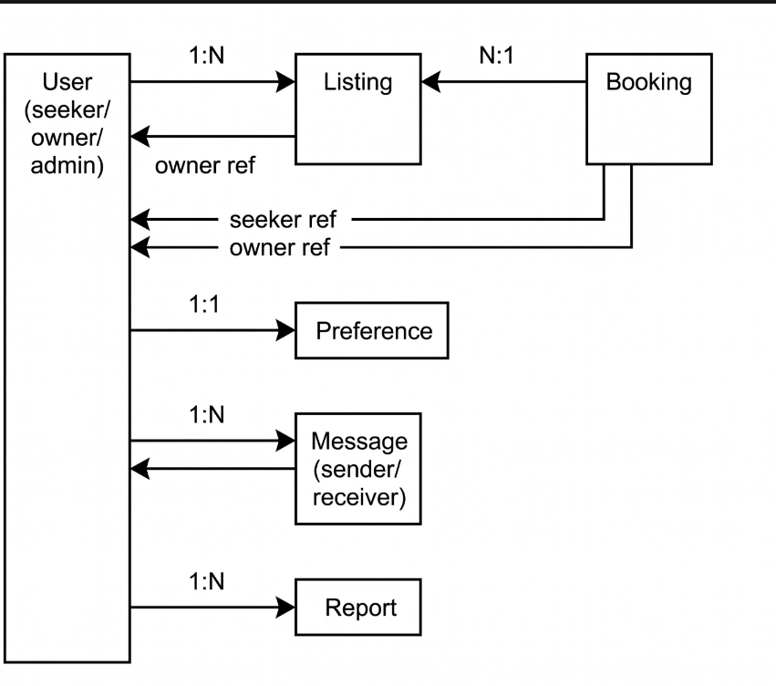

3. Functional Requirements

The functional requirements of this system are organized by module to ensure clarity, maintainability, and traceability throughout the development lifecycle. Each requirement is assigned a unique identifier in the format FR-XXX, which serves as a reference point for design, development, and testing activities.

3.1 User Authentication & Authorization Module
This module governs all aspects of user identity, access control, and session management within the platform.
FR-001 — User Registration: The system shall allow new users to register by providing their full name, email address, password, phone number, and city of residence. During registration, the user must also select a designated role — either Room Owner or Room Seeker — which determines their access privileges throughout the platform.
FR-002 — Email Verification: Upon successful registration, the system shall automatically dispatch a verification email to the provided address. Users are required to verify their email before gaining access to the full feature set of the application.
FR-003 — User Login: The system shall authenticate users through a secure email and password mechanism. Upon successful authentication, a JSON Web Token (JWT) access token shall be issued to maintain the user's session.
FR-004 — Password Reset: The system shall provide a Forgot Password workflow that generates and sends a time-limited password reset link to the user's registered email address, enabling secure account recovery.
FR-005 — Profile Management: Authenticated users shall have the ability to update their personal profile at any time, including their profile picture, contact details, bio, and account preferences.
FR-006 — Role-Based Access Control: The system shall enforce strict role-based access control (RBAC). Room Owners, Room Seekers, and Administrators shall each have distinct permission sets, with restricted access to dashboards and features that fall outside their designated role.
FR-007 — Logout: The system shall provide a logout mechanism that invalidates the current JWT session on the client side, ensuring secure termination of the user's active session.

3.2 Room Listing Management Module (Room Owner)
This module provides Room Owners with full control over the creation, management, and availability of their room listings.
FR-008 — Create Listing: Room Owners shall be able to create a new room listing by supplying comprehensive details, including a title, description, address, city, monthly rent in PKR, room type (single, shared, studio, or apartment), maximum occupancy, gender preference (male, female, or any), available amenities such as WiFi, electricity, gas, furnished fittings, air conditioning, and attached bathroom, along with a maximum of eight photographs.
FR-009 — Edit Listing: Room Owners shall be able to modify any field of an existing listing at any time, including the ability to update or remove individual photographs as needed.
FR-010 — Delete Listing: Room Owners shall be able to permanently delete a listing from the platform. Upon deletion, all associated booking requests and uploaded photographs shall be automatically removed from the system.
FR-011 — Availability Toggle: Room Owners shall be able to mark a listing as either Available or Not Available without the need to delete it, allowing flexible management of room status.
FR-012 — Owner Dashboard: Room Owners shall have access to a dedicated dashboard that provides an overview of all active listings, the total number of booking requests received, a breakdown of pending, accepted, and rejected requests, and a count of unread messages.
FR-013 — Manage Booking Requests: Room Owners shall be able to review all incoming booking requests associated with their listings and take action by accepting or rejecting each request, with the option to include a short explanatory message to the Room Seeker.

3.3 Room Search & Discovery Module (Room Seeker)
This module enables users to discover, browse, and interact with available room listings through a range of search and filtering capabilities.
FR-014 — Browse Listings: Both unauthenticated and authenticated users shall be able to browse all currently available room listings. Results shall be displayed with paginated navigation, presenting ten listings per page.
FR-015 — Search by Keyword: Users shall be able to perform keyword-based searches against listing titles, descriptions, and city fields, enabling quick and targeted discovery of relevant rooms.
FR-016 — Filter Listings: Users shall be able to apply multiple simultaneous filters to refine search results, including city, price range (minimum to maximum in PKR), room type, gender preference, and specific amenities such as WiFi, furnished status, air conditioning, and others.
FR-017 — Sort Listings: Users shall be able to sort the displayed search results using one of the following criteria: newest first, price low to high, price high to low, or highest rated.
FR-018 — View Listing Detail: Users shall be able to access a comprehensive listing detail page that presents all uploaded photographs in a carousel viewer, a full description, a list of amenities, an owner profile snippet, an interactive location map pin, and associated user reviews.
FR-019 — Save to Wishlist: Authenticated Room Seekers shall be able to save any listing to a personal wishlist for future reference, and shall be able to remove listings from the wishlist at any time.
FR-020 — Send Booking Request: Authenticated Room Seekers shall be able to submit a booking request to a listing owner by specifying a preferred move-in date and an optional message. The system shall enforce a rule allowing only one active booking request per listing per seeker at any given time.
FR-021 — Track Booking Status: Room Seekers shall be able to monitor the current status of all their submitted booking requests — whether Pending, Accepted, or Rejected — from a centralised section within their personal dashboard.

3.4 Roommate Compatibility Matching Module

This module facilitates the intelligent matching of Room Seekers based on lifestyle compatibility, helping users find roommates who align with their living preferences.
FR-022 — Compatibility Questionnaire: Room Seekers shall be able to complete a structured lifestyle questionnaire that captures key personal habits and preferences, including sleep schedule, cleanliness standards, noise tolerance, cooking habits, smoking and drinking behaviour, study or work hours, guest frequency, and pet tolerance.
FR-023 — Compatibility Score Calculation: The system shall process questionnaire responses using a weighted matching algorithm to calculate a compatibility percentage score between any two Room Seekers, providing a quantitative basis for roommate recommendations.
FR-024 — Browse Potential Roommates: Room Seekers who have completed the lifestyle questionnaire shall be able to browse other seekers located in the same city. Results shall be sorted by compatibility score in descending order, displaying the most compatible matches first.
FR-025 — Roommate Profile View: Room Seekers shall be able to view the public profile of a potential roommate, which includes their computed compatibility score, bio, city, occupation type, and a summary of shared lifestyle preferences.
FR-026 — Connect with Roommate: Room Seekers shall be able to initiate a direct chat conversation with a potential roommate directly from the compatibility results page, facilitating seamless communication between matched users.

3.5 Real-time Chat Module
This module provides a real-time messaging infrastructure enabling direct communication between platform users.
FR-027 — Initiate Conversation: Authenticated users, regardless of their role as Owner or Seeker, shall be able to initiate a chat conversation with another user. Each conversation is unique per user pair, ensuring organised and non-duplicated communication threads.
FR-028 — Send & Receive Messages: Users shall be able to send and receive plain text messages in real time, powered by Socket.io. All messages shall be automatically timestamped upon delivery.
FR-029 — Conversation List: The chat inbox shall present a consolidated list of all active conversations, displaying each contact's name, a preview of the last message, the timestamp of the most recent interaction, and an unread message count badge.
FR-030 — Online Presence Indicator: The system shall display a real-time online or offline status indicator for users within an active conversation, allowing participants to know when the other party is currently available.
FR-031 — Message Persistence: All chat messages shall be persistently stored in MongoDB, ensuring that complete conversation history remains accessible to users upon reconnection or future sessions.

3.6 Review & Rating Module
This module enables Room Seekers to provide feedback on their accommodation experience, contributing to the platform's transparency and trustworthiness.
FR-032 — Submit Review: Room Seekers who have an accepted booking associated with a listing shall be able to submit a star rating on a scale of one to five, along with a written review. Only one review per booking is permitted to maintain authenticity.
FR-033 — View Reviews: All users, regardless of authentication status, shall be able to view the complete list of reviews for a listing on its detail page. Each review shall display the reviewer's name, star rating, written feedback, and submission date.
FR-034 — Average Rating Display: The system shall automatically calculate and prominently display the average star rating and the total number of reviews on each listing card and on the full listing detail page.
FR-035 — Edit or Delete Review: Room Seekers shall retain the ability to edit or permanently delete their own submitted review within seven days of the original submission date.

3.7 Notification Module
This module keeps users informed of relevant platform activities through real-time in-app notifications.
FR-036 — In-App Notifications: The system shall automatically generate in-app notifications for the following events: receipt of a new booking request (for owners), a status update on a booking request (for seekers), receipt of a new chat message, and submission of a new review on a listing.
FR-037 — Notification Badge: The main navigation bar shall display a live unread notification count badge. This badge shall update in real time via Socket.io, ensuring users are always aware of new activity without requiring a page refresh.
FR-038 — Mark as Read: Users shall be able to mark individual notifications as read or dismiss all notifications at once using a single action, keeping their notification centre organised.

3.8 Admin Dashboard Module
This module provides platform administrators with the tools necessary to monitor system activity, manage users and content, and enforce community standards.
FR-039 — Platform Analytics: The Administrator shall have access to a high-level summary dashboard presenting key platform metrics, including the total number of registered users broken down by role, total active listings, total bookings processed, new registrations within the last 30 days, and a breakdown of the most popular cities on the platform.
FR-040 — User Management: The Administrator shall be able to view the complete list of registered users, search by name or email address, inspect individual user profiles, and take administrative action by banning or unbanning accounts as appropriate.
FR-041 — Listing Management: The Administrator shall be able to access all listings on the platform, apply filters by listing status, and remove any listing that is found to violate the platform's content policies or community guidelines.
FR-042 — Reports Management: The Administrator shall be able to review all user-submitted reports concerning flagged listings or users, and take appropriate action on each report, including dismissing the report, issuing a warning to the reported party, or banning the offending account.
FR-043 — Report a Listing or User: Authenticated users shall be able to submit a report against any listing or another user for inappropriate content or unacceptable behaviour. All submitted reports shall be forwarded directly to the Administrator's dashboard for review.

4. Non-Functional Requirements

4.1 Performance Requirements

The following non-functional requirements define the minimum performance standards the system must meet to deliver a reliable and responsive user experience.
NFR-001 — Page Load Time: The initial page load time shall not exceed three seconds when accessed over a 10 Mbps internet connection. Subsequent navigation within the Single Page Application (SPA) shall complete within one second to ensure a smooth and fluid user experience.
NFR-002 — API Response Time: All REST API endpoints shall return responses within 500 milliseconds under normal operating load. Database queries shall be optimised through appropriate indexing strategies to meet this target consistently.
NFR-003 — Real-Time Latency: Chat messages transmitted through the platform shall be delivered in real time, with a target end-to-end latency of under 200 milliseconds on a stable network connection.
NFR-004 — Concurrent Users: The system shall be capable of supporting a minimum of 100 simultaneous concurrent users without any measurable degradation in performance or responsiveness.
NFR-005 — Image Optimisation: All photographs uploaded to the platform shall be automatically compressed and served in optimised modern formats, specifically WebP, through Cloudinary's transformation pipeline, reducing bandwidth consumption and improving load times.

4.2 Security Requirements
- NFR-006: All user passwords shall be hashed using bcrypt with a minimum salt round of 10 before storage in the database.
- NFR-007: All API communication shall occur over HTTPS. HTTP requests shall be redirected to HTTPS.
- NFR-008: JWT access tokens shall have an expiration of 7 days. Expired tokens shall be rejected with a 401 Unauthorized response.
- NFR-009: All API inputs shall be validated and sanitized on the server side to prevent injection attacks (SQL injection equivalent for MongoDB — NoSQL injection).
- NFR-010: CORS (Cross-Origin Resource Sharing) shall be configured to allow requests only from the designated frontend origin.
- NFR-011: Sensitive environment variables (JWT secret, MongoDB URI, Cloudinary keys) shall be stored in environment files (.env) and never committed to the repository.
- NFR-012: Rate limiting shall be applied to authentication endpoints to prevent brute-force attacks (maximum 10 requests per minute per IP).
- NFR-013: Admin routes shall be protected by both JWT authentication and role verification middleware.

4.3 Usability Requirements
- NFR-014: The UI shall be fully responsive and usable on devices with screen widths from 375px (mobile) to 1920px (desktop) without horizontal scrolling.
- NFR-015: The application shall provide clear feedback for all user actions — loading spinners for pending operations, success notifications (toast messages), and descriptive error messages.
- NFR-016: All form inputs shall display inline validation errors before form submission.
- NFR-017: Critical destructive actions (delete listing, remove account) shall require user confirmation via a modal dialog.
- NFR-018: The platform shall be navigable in a maximum of 3 clicks from the home page to any primary feature.
- NFR-019: The UI shall follow a consistent color scheme, typography, and spacing system throughout (implemented via Tailwind CSS design tokens).

4.4 Reliability & Availability
- NFR-020: The system shall target 99% uptime during the academic evaluation period.
- NFR-021: The application shall handle API errors gracefully — network failures shall display user-friendly error messages rather than crashing.
- NFR-022: MongoDB Atlas automatic backups shall be enabled to prevent data loss.
- NFR-023: The system shall not lose any chat message due to network disconnection; Socket.io shall reconnect automatically.

4.5 Maintainability & Scalability
- NFR-024: The codebase shall follow a modular MVC (Model-View-Controller) architecture on the backend for separation of concerns.
- NFR-025: The frontend shall use a component-based architecture (React) with reusable UI components.
- NFR-026: All API endpoints shall be documented with clear naming conventions following RESTful standards.
- NFR-027: The system shall be designed to allow horizontal scaling — additional server instances can be added without architectural changes.
- NFR-028: MongoDB indexes shall be defined on frequently queried fields (city, price, roomType) to support future scale.

4.6 Portability Requirements
- NFR-029: The backend shall be OS-agnostic and deployable on any Linux-based cloud platform supporting Node.js v18+.
- NFR-030: The frontend SPA shall function correctly on all major browsers (Chrome, Firefox, Edge, Safari) without browser-specific polyfills beyond standard Vite build output.

5. System Models

5.1 Use Case Descriptions
The following table describes the primary use cases of the RoomBridge system. Actors include Room Owner (RO), Room Seeker (RS), and Admin (AD).

Use Case ID | Actor(s) | Use Case Name | Precondition | Postcondition
UC-001 | RS, RO | Register Account | User is not registered | New account created; verification email sent
UC-002 | RS, RO, AD | Login to System | User has a verified account | JWT issued; user directed to role dashboard
UC-003 | RO | Create Room Listing | Owner is authenticated | New listing visible to seekers
UC-004 | RS | Search & Filter Rooms | System has available listings | Matching listings displayed to seeker
UC-005 | RS | Send Booking Request | Seeker authenticated; listing available | Request created with Pending status; owner notified
UC-006 | RO | Accept/Reject Booking | Pending booking request exists | Request status updated; seeker notified
UC-007 | RS | Complete Questionnaire | Seeker is authenticated | Profile tagged for matching; compatibility becomes visible
UC-008 | RS | Browse Roommate Matches | Seeker has completed questionnaire | List of seekers with compatibility scores displayed
UC-009 | RS, RO | Chat with User | Both parties authenticated | Messages delivered in real time and persisted
UC-010 | RS | Submit Room Review | Seeker has an accepted booking for the listing | Review published; average rating updated
UC-011 | AD | Manage Users & Listings | Admin is authenticated | User/listing status updated across platform

5.2 Data Flow Overview
The data flow in RoomBridge follows a standard client-server RESTful model supplemented by real-time events:

- Step 1 — Client Request: The React SPA sends an HTTP request (GET, POST, PUT, DELETE) to the Express.js API server.
- Step 2 — Middleware Processing: The request passes through Express middleware: CORS validation, rate limiting, JWT authentication verification, input validation.
- Step 3 — Controller Logic: The appropriate controller processes the business logic — querying or updating MongoDB via Mongoose models.
- Step 4 — External Service Calls: Where needed, the server calls Cloudinary (image upload), Gmail SMTP (email), or emits Socket.io events (real-time notifications/chat).
- Step 5 — Response: The server returns a JSON response with appropriate HTTP status codes. The React frontend updates its Redux store and re-renders the UI.

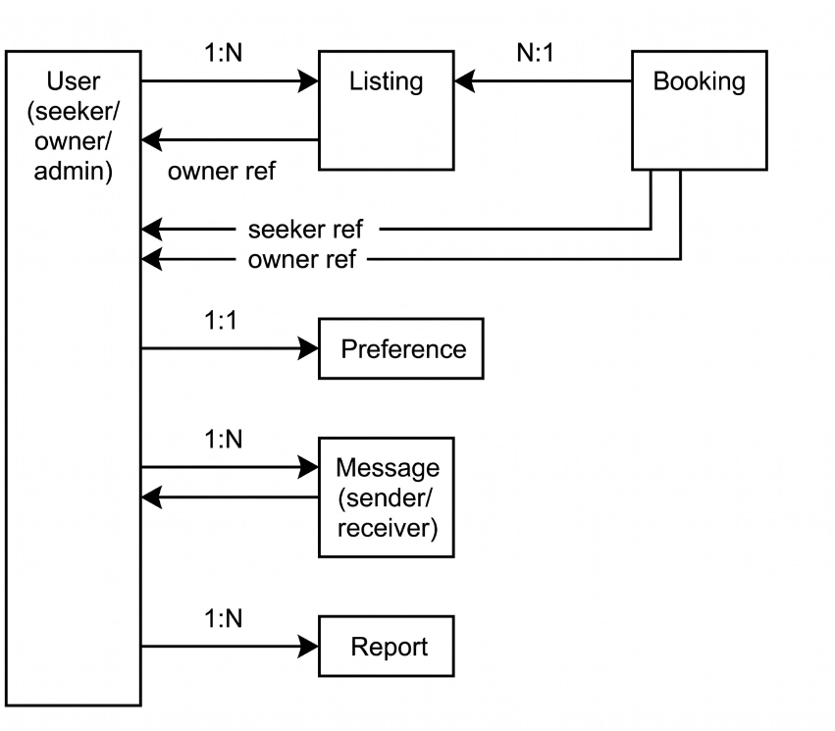

5.3 Database Entity Overview
The following MongoDB collections form the core data model of RoomBridge:

Collection | Key Fields | Purpose
Users | name, email, password, role, city, profilePic, compatibility | Stores all registered users across all roles
Listings | owner, title, city, rent, roomType, amenities, photos, isAvailable | Room listings posted by Room Owners
Bookings | listing, seeker, owner, status, moveInDate, message | Booking requests sent by seekers to owners
Messages | conversationId, sender, receiver, text, created At | Individual chat messages within conversations
Conversations | participants[], last Message, updated At | Chat conversation threads between two users
Reviews | listing, author, rating, text, createdAt | Room reviews submitted by seekers with accepted bookings
Notifications | recipient, type, message, isRead, relatedId | In-app notifications for bookings, messages, and reviews
Reports | reporter, targetType, targetId, reason, status | User-submitted reports of inappropriate listings or users

6. External Interface Requirements

6.1 User Interface
- The frontend shall be a Single Page Application (SPA) built with React.js and Vite, styled with Tailwind CSS.
- The UI shall use a professional blue-dominant color palette reflecting trust and reliability, consistent with the real estate domain.
- Navigation shall include: a top navigation bar (logo, search, notifications bell, user avatar menu) and a role-specific sidebar for dashboard sections.
- Listing cards shall display: the primary photo, title, city, rent per month, room type badge, average rating stars, and a quick 'Save' toggle.
- All modals, dropdowns, and toast notifications shall be accessible and closable via the Escape key.
- The chat interface shall resemble a standard messaging layout (left: conversation list, right: message thread) similar to WhatsApp Web.

6.2 Hardware Interfaces
- The system has no direct hardware interface requirements beyond standard client devices (PC, laptop, smartphone, tablet) with a web browser and internet access.
- Camera/file access for profile pictures and room photos is handled via the browser's native file picker (HTML input type=file); no direct hardware API access is required.

6.3 Software Interfaces
External System | Interface Type | Purpose
MongoDB Atlas | Mongoose ODM / REST | Cloud-hosted NoSQL database for all application data
Cloudinary | REST API / SDK | Image upload, storage, transformation, and delivery via CDN
Gmail SMTP | SMTP / Nodemailer | Sending email verification links and password reset emails
Socket.io | WebSocket / HTTP | Real-time bidirectional events for chat and notifications
GitHub | Git / HTTPS | Source code version control and repository hosting

6.4 Communication Interfaces
- All HTTP communication between frontend and backend shall use HTTPS (TLS 1.2 or higher) to ensure data encryption in transit.
- The REST API shall use JSON as the data interchange format for all request bodies and responses.
- Real-time events (chat, notifications) shall be transmitted over WebSocket connections managed by Socket.io, with automatic fallback to HTTP long-polling.
- Email communication (verification, password reset) shall be sent via Gmail SMTP using a dedicated App Password for authentication.

7. Appendices

7.1 Appendix A — Roommate Compatibility Questionnaire

The following 10-question questionnaire is presented to Room Seekers during profile setup. Each response is stored as a value used in the compatibility scoring algorithm. Questions are presented as single-choice radio buttons.

# | Question | Options
Q1 | Sleep Schedule | Early Bird (before 10 PM) | Night Owl (after midnight) | Flexible
Q2 | Cleanliness Standard | Very Clean (daily tidying) | Moderate (weekly) | Relaxed (as needed)
Q3 | Noise Tolerance | Complete Quiet | Some Noise OK | Noise doesn't bother me
Q4 | Cooking Habits | Cook daily | Cook occasionally | Rarely/Never cook
Q5 | Smoking Habits | Non-smoker | Smoker (outdoors only) | Smoker
Q6 | Guests & Visitors | No guests | Occasional guests | Frequent guests
Q7 | Study / Work from Home | Always WFH/Study at home | Sometimes | Rarely at home
Q8 | Pet Tolerance | Love pets | Allergic/No pets | Neutral
Q9 | Shared Space Usage | Prefer shared (social) | Neutral | Prefer separate spaces
Q10 | Gender Preference for Roommate | Same gender only | Any gender | No preference

7.2 Appendix B — Technology Stack Summary

Layer | Technology | Version / Notes
Frontend Framework | React.js (Vite) | v18+, Single Page Application with fast HMR via Vite
Styling | Tailwind CSS | v3+, utility-first CSS framework
State Management | Redux Toolkit | Centralized state management for auth, listings, chat
Backend Framework | Node.js + Express.js | Node.js v18+, Express.js v4+, RESTful API architecture
Database | MongoDB + Mongoose | MongoDB Atlas cloud cluster; Mongoose v7+ ODM
Authentication | JWT + bcrypt | JSON Web Tokens for stateless auth; bcrypt for password hashing
Real-time | Socket.io | v4+, WebSocket-based real-time communication
File Upload | Multer + Cloudinary | Multer for multipart parsing; Cloudinary SDK for cloud storage
Email | Nodemailer + Gmail | Gmail App Password for SMTP email delivery
Version Control | Git + GitHub | Public repository on GitHub for collaboration and submission

7.3 Appendix C — Requirements Traceability Matrix

The following matrix maps key functional requirements to the user roles they serve:

FR ID | Requirement | Room Owner | Room Seeker | Admin
FR-001–007 | Authentication Module | Yes | Yes | Yes
FR-008–013 | Listing Management | Yes | No | View only
FR-014–021 | Search & Booking | No | Yes | View only
FR-022–026 | Roommate Matching | No | Yes | View only
FR-027–031 | Real-time Chat | Yes | Yes | No
FR-032–035 | Review & Rating | View only | Yes | Manage
FR-036–038 | Notifications | Yes | Yes | Yes
FR-039–043 | Admin Dashboard | No | No | Yes

